

COMMUNITY COLLEGE OF CITY UNIVERSITY

DIVISION OF APPLIED SCIENCE AND TECHNOLOGY

AST20613 Computer System Development

2014-2015

G.V. Calendar

(Google Voice Calendar)

FINAL YEAR PROJECT

USER MANUAL

by

Group:ISD02

WONG, Ho Long(53587834)*

LI, Sing Lun (53612386)

SIN, Sin Chung(53587350)

WONG, Chun Kit(53581516)

Supervised by

Dr. Timothy Kwong

TABLE OF CONTENTS

1. INTRODUCTION

1.1 OBJECTIVES

1.2 MINIMUM SYSTEM REQUIREMENTS

1.3 RECOMMENDED SYSTEM REQUIREMENTS

1.4 SOFTWARE REQUIREMENTS

2. SYSTEM FUNCTION

2.1 ACCOUNT REGISTRATION

2.2 LOGIN

2.3 VOICE INPUT

2.4 VOICE OUTPUT

2.5 CREATE EVENT

2.6 EDIT EVENT

2.7 DELETE EVENT

ACKNOWLEDGEMENTS

1. **INTRODUCTION**
   1. Objectives

This is a guideline to teach users how to use Google Voice Calendar on their mobile device. The following shows the functions that users can use when they browse the webpage with network access.

1. Voice Input
2. Voice Output
3. Create Event
4. Edit Event
5. Delete Event
6. **SYSTEM FUNCTION**
   1. **Voice Input**

Users can use their voice to input the details of the event. The system will help them to covert the voice to the text and show it out to the screen. There is a button like microphone (shown at Figure 2.1) for users to click and let users for using voice to input details.

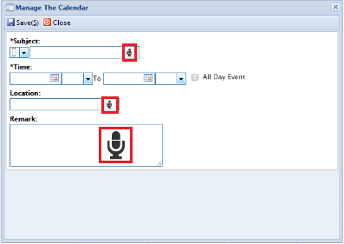

**Figure 2.3** Voice Input

**ACKNOWLEDGEMENTS**

We have taken efforts in this project, it would not have been possible without the kind help and support of many individuals and organizations. We would like to take this chance to extend our sincere thanks of all of them.

We are very thankful to our supervisor, Dr.Timothy Kwong, the guide of the project that help us to solve many problems throughout the project. Also, we are highly indebted for his guidance and constant supervision as well as for providing necessary information regarding the project and also for his support in completing the project. Moreover, his kind concern provides much power to our team to finish the project successfully.

We would also like to express our special gratitude and thanks to the teachers who have taught us in these two years. The knowledge they have taught us is very useful in this project and it helps to fix lots of issues.

The teachers that we owe a great many thanks are: (Names are listed in alphabetical order)

Dr. Desmond Tsoi

Mr. Frank Lau

Mr. Jackie Kwong

Dr. Kenny Ma

Dr. Timothy Kwong

We would also like to thank you all of our groupmates, with all the help and support for doing the development of the project.

Thank you.

Yours sincerely,

Wong Ho Long, Li Sing Lun, Sin Sin Chung, Wong Chun Kit

FYP ISD-02 G.V. Calendar